**DEPARTMENT OF MECHANICAL AND INDUSTRIAL ENGINEERING**

by

**NATHAN ROBINSON**

**ME405, MECHANICAL LAB-III**



***written with passion***



**PERFORMANCE TEST OF A VAPOR COMPRESSION REFRIGERATION CYCLE**

**Table of Contents**

Abstract 3

Introduction 4

Experimental Methodology 5-11

Numerical Analysis (calculations) 12-17

Discussion 18-22

Conclusion 23

References 24

Appendix 25-28

**Table of Figures**

Fig 1; Compressor. 5

Fig 2; Condenser heat exchanger. 6

Fig 3; Evaporator heat exchanger. 6

Fig 4; Fan speed controls and compressor switch. 7

Fig 5; Temperature and pressure gauges. 8

Fig 6; Electrical data gauges. 8

Fig 7; Sling thermometer in slinging position. 9

Fig 8; Sling thermometer in vertical position. 9

Fig 9; Digital Anemometer. 10

Fig 10; Heat exchanger recording locations for anemometer. 11

Fig 11; Test 1-3 P-H diagram. 18

Fig 12; Test 1-3 P-T diagram. 19

Fig 13; Test 1, 4 and 5 P-H diagram. 20

Fig 14; Test 1, 4 and 5 P-H diagram. 20

Table 1; Data sheet including enthalpy 21

**Abstract**

This experiment proved the optimal parameters for a vapor compression refrigeration cycle. By testing different fan speeds it was observed that a high air flow rate through the condenser heat exchanger allows for a greater rate of heat transfer from the refrigeration cycle to the environment and contrary with the evaporator having the lowest wet bulb temperature from test 3 at 46 ̊F at the highest fan speed, which allows a lower rate of heat transfer to the environment at 1,198.659 (lbm/hr).

The compressor allows for the increase in pressure of the refrigerant fluid while it is in vapor state. This pressurization facilitates the phase change inside the condenser and maximizes the heat transfer to the environment. The greater the pressurization in vapor phase the greater the enthalpy change will be across the condenser heat exchanger.

The expansion valve allows for the release of pressure of the refrigerant during the liquid phase, ideally the refrigerant should exit the depressurization device in a saturated state, in order to further facilitate the phase transition offered by the evaporator. Allowing for a minimal amount of heat transfer from the system to environment, through the evaporator heat exchanger. Resulting in overall coefficient of performance (COP)Overall = -3.357.

**Introduction**

The basic need for refrigeration was mainly sprouted from the necessity increasing the longevity of food susceptible to rotting or spoiling due to high climate temperatures. Before the modern refrigeration existed, storage rooms called iceboxes were used to hoard meats and other perishable foods. In order for these rooms to stay cold, ice was kept inside the room and to a certain point the walls were insulated with wood straw and saw dust and this would keep the ice chamber from melting for several months.

In 1834, Jacob Perkins built the first working vapor-compression refrigeration system. The objective of the refrigeration cycle is to provide a constant air flow at a lower temperature than the atmospheric temperature.

Take for example a regular household air conditioner. The refrigeration cycle is setup in such a way that the interior of the house receives an air flow at a lower temperature than the outside. To achieve this low temperature a refrigerant fluid is passed through a compressor in order to pressurize the vapor fluid leading to a condenser surrounded by a heat exchanger. With a fan an air flow is created passing through the condenser heat exchanger toward the outside environment releasing a flow at a higher temperature than the room temperature. As the name dictates the condenser has the purpose to change the phase of the refrigerant fluid from vapor to liquid in order to maximize the effect of depressurization effect from the expansion valve. The fluid then proceeds to the next component of the cycle, a depressurizing device, usually an expansion valve leading to an evaporator. A second air flow is created to pass through a heat exchanger surrounding the evaporator toward the inside of the house delivering a flow with lower temperature than the room temperature. At the evaporator outlet the refrigerant fluid is completely in vapor state in order to maximize the effect of pressurizing the fluid, leading into the compressor once again to create a continuous cycle, thus keeping the household nice and cool.

**Experimental Methodology**

This experiment was carried out by using a Carrier Refrigeration Cycle Trainer; the cycle components are placed vertically on the setup panel in order to facilitate the visualization of the model, as well as to allow for the reading and recording of the data through the various gauges. The refrigeration components of this cycle include a compressor, a condenser, a thermostatic expansion valve and an evaporator. The setup panel also includes an oversized thermostatic expansion valve and a capillary tube, both as expansion devices. For this experiment however only the regular expansion valve was used. Figures of various components are shown below.

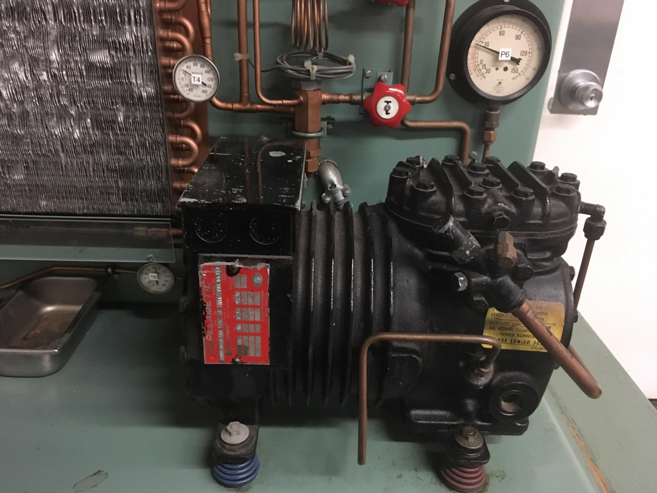

Fig 1; Compressor.

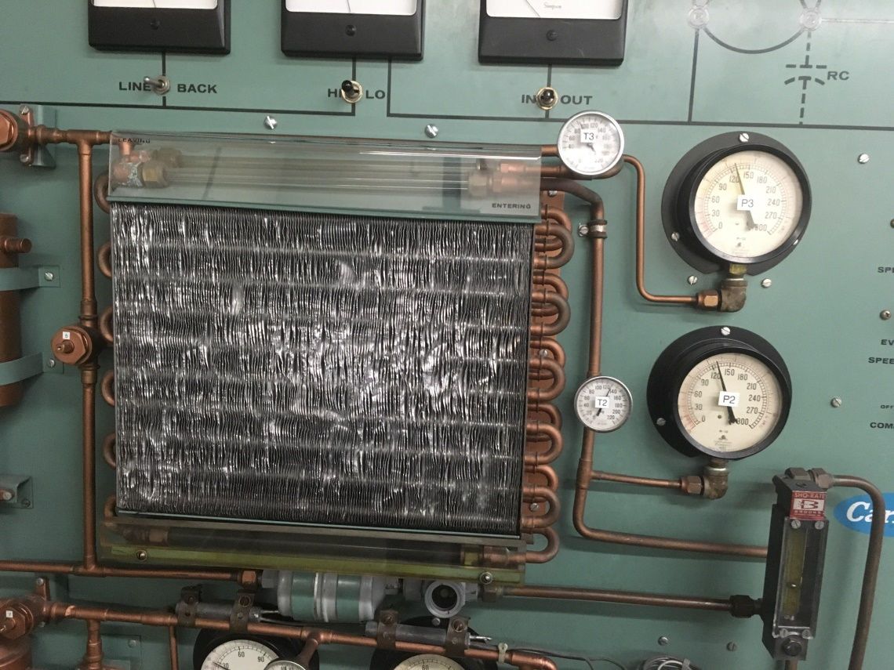

Fig 2; Condenser heat exchanger.

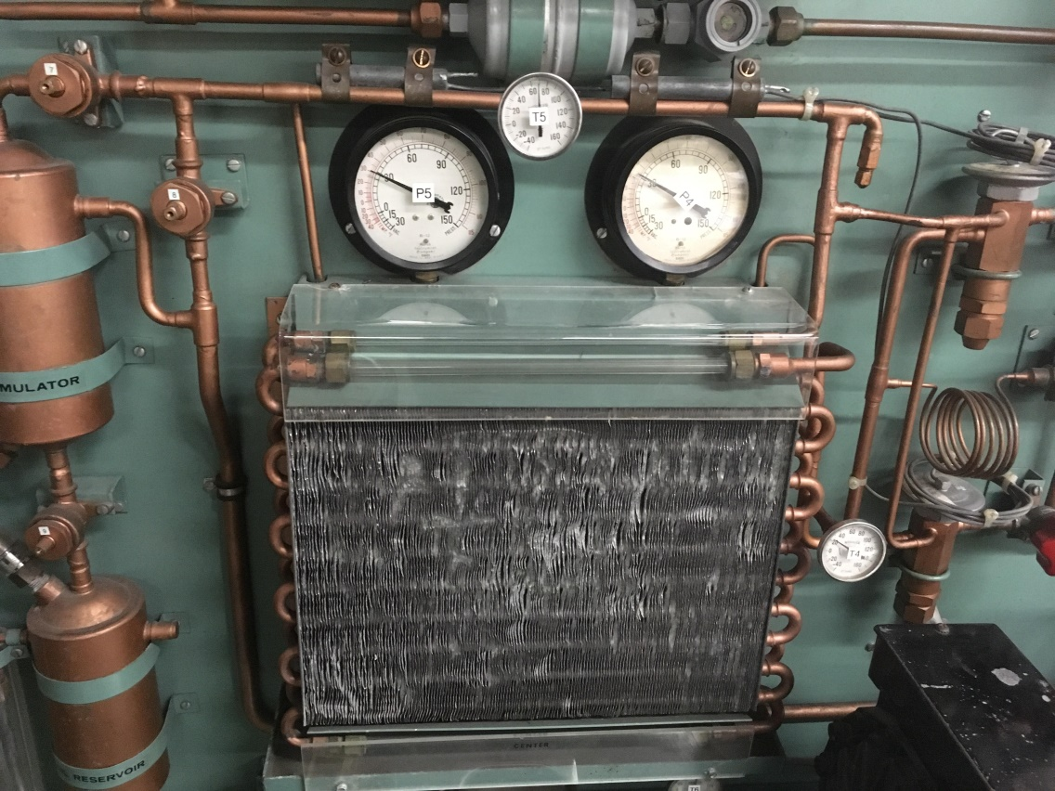

Fig 3; Evaporator heat exchanger.

A total of 5 tests were ran each test varying by changing the setting the airflow of both the compressor and the evaporator. The fan setting include high, medium and low for both heat exchangers. The 5 combinations for the fan speeds used for this experiment are represented as follows (H H), (H M), (H L), (L H) and (M H) across the condenser and evaporator accordingly. “H” representing high, “M” medium and “L” low.

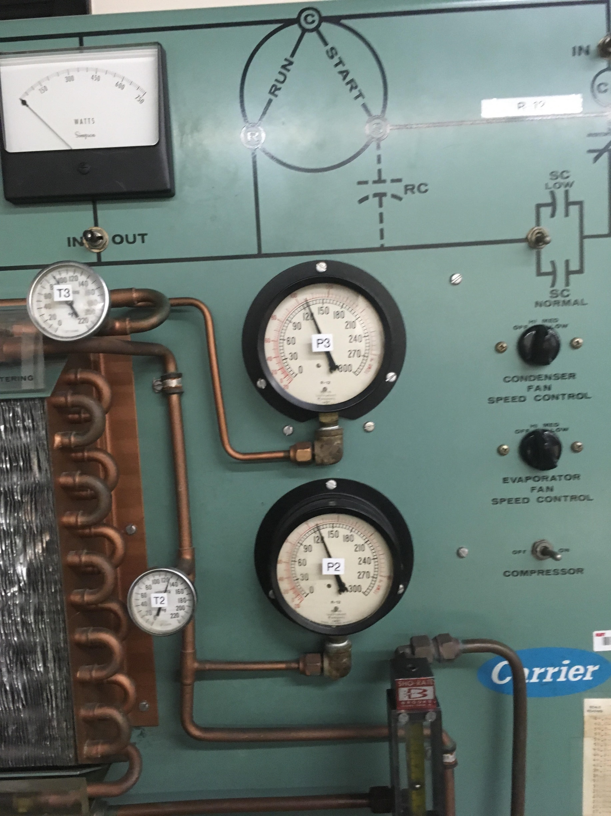

Fig 4; Fan speed controls and compressor switch.

The setup panel also includes a total of 6 pressure gauges and 6 temperature gauges, both labeled 1 through 6. These gauges were placed systematically to takes the readings of the pressure and temperature of the cooling fluid being used for the cycle. In this experiment the refrigerant being used is R-12. The gauge recordings include both the inlet and outlet readings of the compressor, condenser and the evaporator. The units for the pressure and temperature gauges readings are in PSIG and Fahrenheit respectively. All 12 gauge readings were taken for each of the 5 tests. It was suggested to wait until the system reached thermal equilibrium before recording the data after initially setting up the fan speeds for each test. 30 seconds were waited for the system to obtain thermal equilibrium.

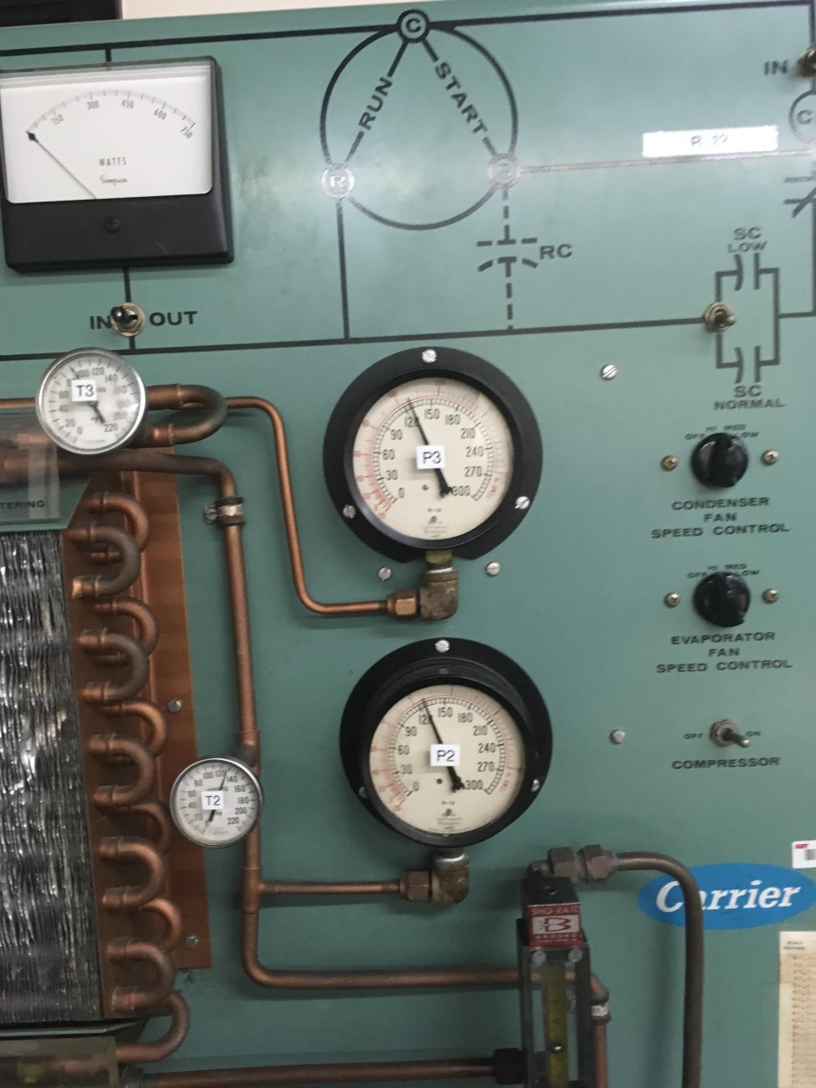

Fig 5; Temperature and pressure gauges.

Electrical data was also obtained through this experimental setup with the aid of voltage, wattage and electric current gauges placed at the top of the setup panel. The voltage gage allows for a switch choice reading of both the line voltage and the back electromotive force (back E.M.F). The units for the voltage, wattage and electric current gauges are in Volts, Watts and Amperes respectively.

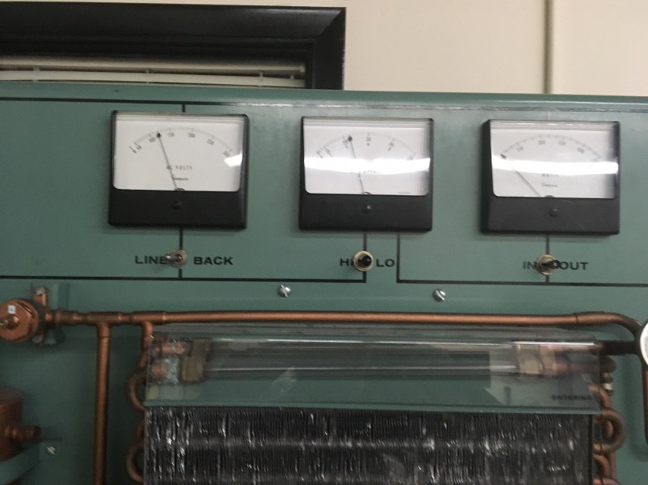

Fig 6; Electrical data gauges.

A device called sling thermometer was used in order to obtain three average temperature readings. The average temperature of the air exiting both heat exchangers of the condenser and the evaporator, as well as the room air temperature entering the back side of the fans. The thermometer used gave both wet and dry bulb readings. All temperature readings were taken in Fahrenheit. An interesting fact about this instrument is that it must be spun around the air flow area in circles manually with the handle, and some of my lab partners said it looks humorous.

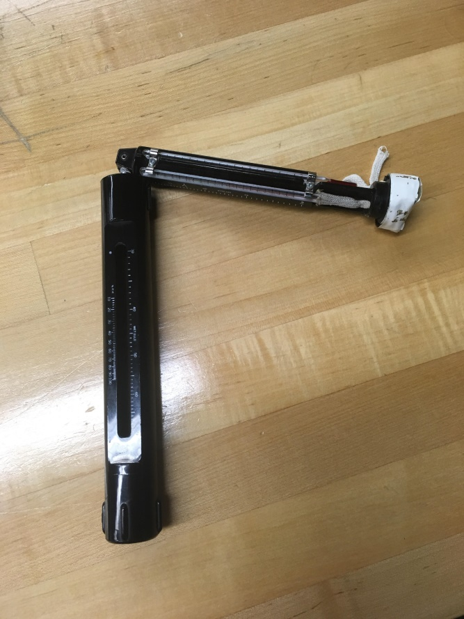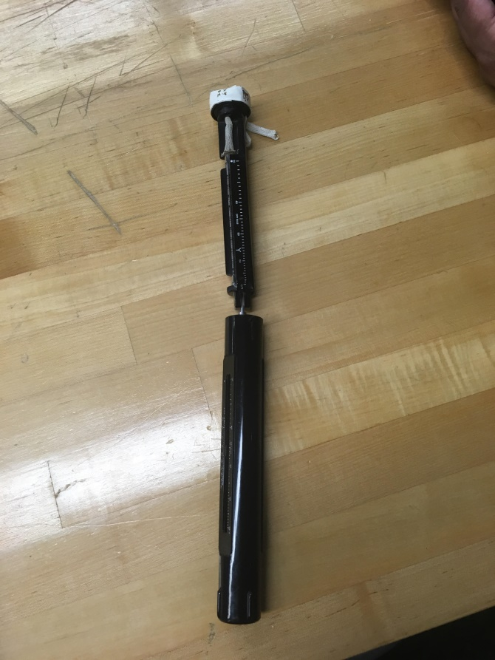

Fig 7; Sling thermometer in slinging position. Fig 8; Sling thermometer in vertical position.

The air flow velocity was obtained with the aid of a digital device called anemometer. This device contains a built in fan at the top that must be held in front of the air flow to be measured.

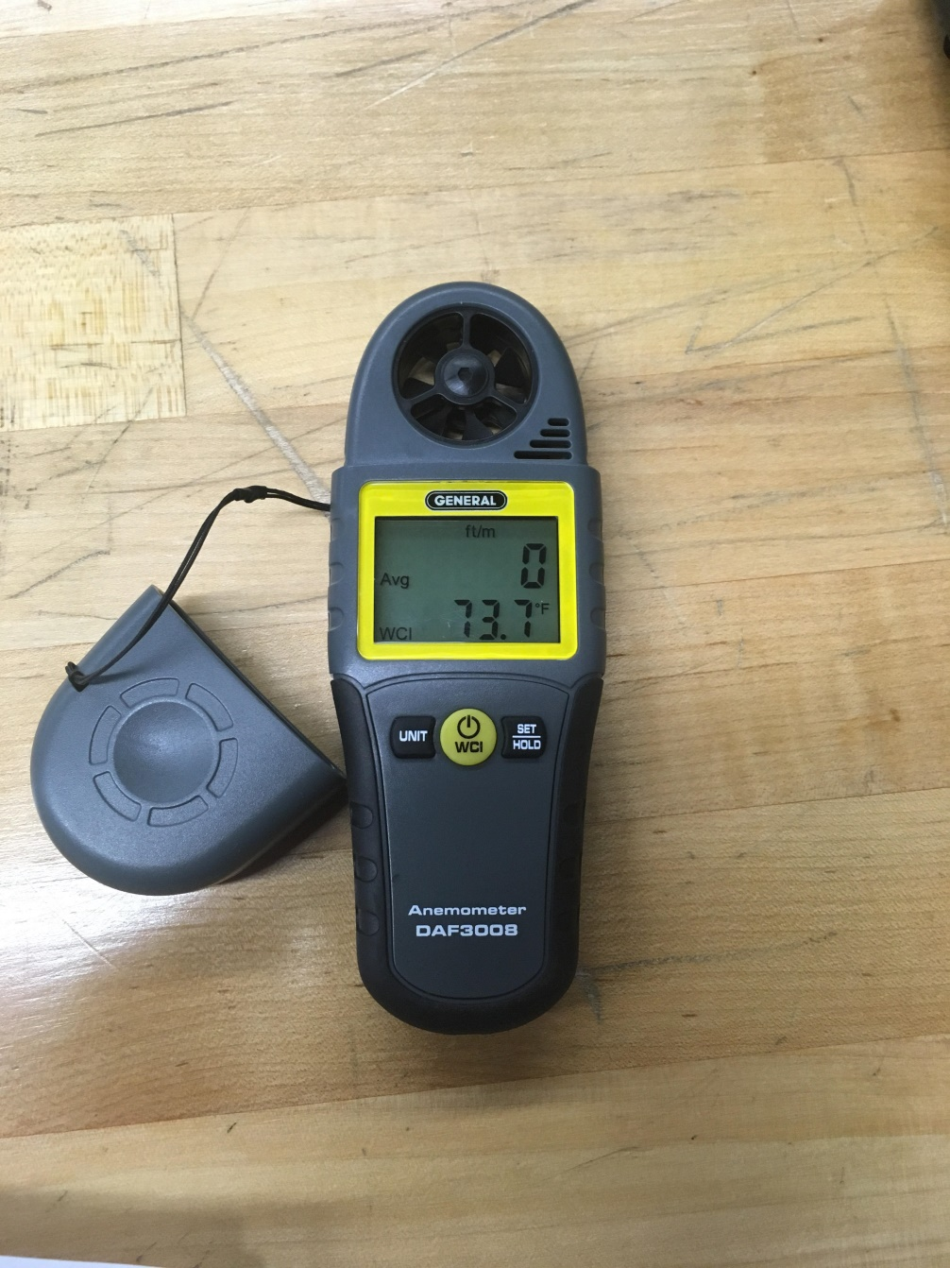

Fig 9; Digital Anemometer.

The anemometer fan could not cover the entirety of the air flow cross-section; hence 5 readings at separate locations were taken for each heat exchanger in order to obtain an average air. The locations of the 5 readings taken were at the four corners and the center of the rectangular shaped heat exchangers.

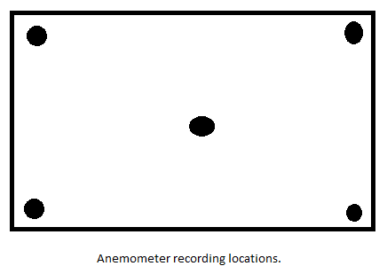

Fig 10; Heat exchanger recording locations for anemometer.

**Calculations for test 3**

**a) Mass flow rate of refrigerant**

ṀR-12 = V̇R-12/טf (lbm/hr)

V̇R-12 = 0.4 (L/min) * 0.0353147 (ft3/min)/(L/min) 🡪 V̇R-12 = 0.014126 (ft3/min)

(טf)obtained by interpolation from saturation properties table at Tavg = 65.2 ̊F

65.2 – 60/ טf – 0.011913 = 70 – 60/0.012089 – 0.011913 🡪 טf = 0.012005 (ft3/lbm)

ṀR-12 = 1.1767 (lbm/min) * (60min/hr) 🡪 ṀR-12 = 70.6 (lbm/hr)

**b) Enthalpies of R-12**

Compressor

(h6 and h1) obtained by interpolation from super-heated vapor properties table

Entering: h6 at T6 = 63 ̊F ; P6 = 24 PSIG

63 – 60/h6 – 85.258 = 70 – 60/86.788 – 85.258 🡪 h6 = 85.717 (Btu/lbm)

Exiting: h1 at T1 = 134 ̊F ; P1 = 115 PSIG

134 – 130/h1 – 92.563 = 140 – 130/94.335 – 92.563 🡪 h1 = 93.272 (Btu/lbm)

Condenser

(h2) obtained by interpolation from super-heated vapor properties table

Entering: h2 at T2 = 124 ̊F ; P2 = 115 PSIG

124 – 120/h2 – 90.775 = 130 – 120/92.563 – 90.775 🡪 h2 = 91.49 (Btu/lbm)

(h3) obtained from saturation table equal to hf value

Exiting: h3 at T3 = 84 ̊F ; P3 = 115 PSIG

hf = h3 = 27.3 (Btu/lbm)

Evaporator

(h4) obtained from saturation table equal to hf value

Entering: h4 at T4 = 22 ̊F ; P2 = 30 PSIG

hf = h4 = 13.3 (Btu/lbm)

(h5) obtained by interpolation from super-heated vapor properties table

Exiting: h5 at T5 = 64 ̊F ; P5 = 26 PSIG

64 – 60/h5 – 85.05 = 70 – 60/86.69 – 85.05 🡪 h5 = 85.706 (Btu/lbm)

**c) Mass flow rate of air**

Condenser

ṀAir = Patm * V̇con/R * Tatm (lbm/hr)

Tatm = 72 ̊F = 295.372 ̊K ; Patm = 1 atm

R = 0.082 (L*atm/K*mol) = 0.002896 (ft3*atm/k*mol)

V̇con = Vavg * A ; Vavg = 633.8 (ft/min) ; A = 0.82465 ft2

V̇con = 522.66 (ft3/min)

ṀAir = 610.29 (mol/min) * (0.0638 lbm/mol) * (60 min/hr) 🡪 ṀAir = 2,336.21 (lbm/hr)

Evaporator

ṀAir = Patm * V̇eva/R * Tatm (lbm/hr)

Tatm = 72 ̊F = 295.372 ̊K ; Patm = 1 atm

R = 0.082 (L*atm/K*mol) = 0.002896 (ft3*atm/k*mol)

V̇eva = Vavg * A ; Vavg = 324.8 (ft/min) ; A = 0.82465 ft2

V̇eva = 267.85 (ft3/min)

ṀAir = 313.129 (mol/min) * (0.0638 lbm/mol) * (60 min/hr) 🡪 ṀAir = 1,198.659 (lbm/hr)

**d) Enthalpies of air (Psychrometric chart)**

Condenser

Entering: hAir at TWB = 54 ̊F

hAir = 22.8 (Btu/lbm)

Exiting: hAir at TWB = 56 ̊F

hAir = 23.2 (Btu/lbm)

Evaporator

Entering: hAir at TWB = 54 ̊F

hAir = 22.8 (Btu/lbm)

Exiting: hAir at TWB = 46 ̊F

hAir = 18.5 (Btu/lbm)

**e) Heat transfer rates**

Condenser

R-12

Q̇R-12 = ṀR-12 * [h2 – h3] (Btu/hr)

ṀR-12 = 70.6 (lbm/hr) ; h2 = 91.49 (Btu/lbm) ; h3 = 27.3 (Btu/lbm)

Q̇R-12 = 4,531.8 (Btu/hr)

Air

Q̇Air = ṀAir * **⧍**hAir (Btu/hr)

ṀAir = 2,336.21 (lbm/hr) ; **⧍**hAir = 23.2 – 22.8 = 0.4 (Btu/lbm)

Q̇Air = 934.484 (Btu/hr)

Evaporator

R-12

Q̇R-12 = ṀR-12 * [h5 – h4] (Btu/hr)

ṀR-12 = 70.6 (lbm/hr) ; h5 = 85.706 (Btu/lbm) ; h4 = 13.3 (Btu/lbm)

Q̇R-12 = 5,111.86 (Btu/hr)

Air

Q̇Air = ṀAir * **⧍**hAir (Btu/hr)

ṀAir = 1,198.659 (lbm/hr) ; **⧍**hAir = 18.5 – 22.8 = -4.3 (Btu/lbm)

Q̇Air = -5,154.23 (Btu/hr)

**f) Power input cycle**

Refrigerant

ẆIn = ṀR-12 [h1 – h6] (Btu/hr)

ṀR-12 = 70.6 (lbm/hr) ; h1 = 93.272 (Btu/lbm) ; h6 = 85.717 (Btu/lbm)

ẆIn = 533.383 (Btu/hr)

Electrical

ẆIn = (Volts * Amps) = Wattage (Btu/hr)

ẆIn = 450 W * (3.412142 (Btu/hr)/W) 🡪 ẆIn = 1,535.4639 (Btu/hr)

**g) COP for Refrigerator**

(COP)R = Q̇Evap/ẆIn = h5 – h4/h1 – h6

h5 = 85.706 (Btu/lbm) ; h4 = 13.3 (Btu/lbm)

h1 = 93.272 (Btu/lbm) ; h6 = 85.717 (Btu/lbm)

(COP)R = 9.584

**h) COP for Heat Pump**

(COP)HP = Q̇Cond/ẆIn = h2 – h3/h1 – h6

h2 = 91.49 (Btu/lbm) ; h3 = 27.3 (Btu/lbm)

h1 = 93.272 (Btu/lbm) ; h6 = 85.717 (Btu/lbm)

(COP)HP = 8.496

**i) Overall COP for Refrigerator**

(COP)Overall = Q̇Evap,Air/ẆIn,Electrical

Q̇Evap,Air = -5,154.23 (Btu/hr) ; ẆIn,Electrical = 1,535.4639 (Btu/hr)

(COP)Overall = -3.357

**j) Capacity of the system**

Evaporator capacity: Q̇Evap,Freon in Tons ; 1 Ton = 12,000 (Btu/hr)

Q̇Evap,Freon = 5,111.86 (Btu/hr) * (Ton/12,000 (Btu/hr)) 🡪 Q̇Evap,Freon = 0.426 Tons

**Discussion**

Tests 1-3 varied in that only the fan speed of the evaporator was changer from High to medium to low respectively. When plotting the pressure (PSIG) against the Enthalpy (Btu/lbm) it can be observed that the refrigerant in test 1 has the lowest enthalpy of 87.2 obtained from the data recorded at gauge 1 when exiting the compressor, and test three has the highest with 93.272. This is the result of the fan in test 3 is running on the slowest setting which creates a lower mass flow rate of air with 1,198.659 (lbm/hr) passing through the heat exchanger than that of test 1. Consequently the Heat transfer to the system is also lower at -5,154.23 (Btu/hr) creating a greater enthalpy change from gauge 6-1 from test 3 at 7.555 (Btu/lbm), compared to the lower change from test 3 at 1.024 (Btu/lbm).

Fig 11; Test 1-3 P-H diagram.

Fig 12; Test 1-3 P-T diagram.

Tests 1, 4 and 5 vary in the condenser fan setting. When observing the P-H diagrams for these three tests, the pressure differences amongst the test are distinguishably noticeable compared to the differences amongst the first three test. Test 1 gives an output reading of 114 (PSIG) at gauge 1, test 4 however with the lowest condenser fan speed has a pressure of 133 (PSIG) at the same point within the cycle. This is due to the change in mass flow rate through the condenser heat exchanger.

Fig 13; Test 1, 4 and 5 P-H diagram.

Fig 14; Test 1, 4 and 5 P-H diagram.

Table 1; Data sheet including enthalpy

|  |  |  |  |  |  |  |  |
| --- | --- | --- | --- | --- | --- | --- | --- |
| ENTRY |  |  | Test 1 (H H) | Test 2 (H M) | Test 3 (H L) | Test 4 (L H) | Test 5 (M H) |
| Volume flow rate of refrigerant (R-12) |  | L/MIN | 0.4 | 0.4 | 0.4 | 0.4 | 0.4 |
| Mass flow rate of refrigerant (R-12) |  | lbm/HR | 70.6 | 70.6 | 70.6 | 70.6 | 70.6 |
|  |  |  |  |  |  |  |  |
| COMPRESSOR |  |  |  |  |  |  |  |
| Entering temperature | **T6** | F | 66 | 64 | 63 | 66 | 67 |
| Entering pressure | **P6** | PSIG | 24 | 23 | 24 | 47 | 25 |
| Entering enthalpy | **H6** | Btu/lbm | 86.176 | 85.95 | 85.717 | 86.42 | 86.11 |
| Leaving temperature | **T1** | F | 100 | 124 | 134 | 138 | 140 |
| Leaving pressure | **P1** | PSIG | 114 | 115 | 115 | 133 | 127 |
| Leaving enthalpy | **H1** | Btu/lbm | 87.2 | 91.55 | 93.272 | 93.45 | 93.81 |
|  |  |  |  |  |  |  |  |
| CONDENSER (Refrigerant-side) |  |  |  |  |  |  |  |
| Entering temperature | **T2** | F | 98 | 116 | 124 | 123 | 128 |
| Entering pressure | **P2** | PSIG | 115 | 115 | 115 | 134 | 127 |
| Entering enthalpy | **H2** | Btu/lbm | 56.2 | 89.85 | 91.49 | 90.45 | 91.95 |
| Leaving temperature | **T3** | F | 82 | 84 | 84 | 93 | 92 |
| Leaving pressure | **P3** | PSIG | 112 | 115 | 115 | 135 | 126 |
| Leaving enthalpy | **H3** | Btu/lbm | 26.832 | 27.3 | 27.3 | 29.425 | 29.187 |
|  |  |  |  |  |  |  |  |
| EVAPORATOR |  |  |  |  |  |  |  |
| Entering temperature | **T4** | F | 22 | 22 | 22 | 26 | 24 |
| Entering pressure | **P4** | PSIG | 30 | 29 | 30 | 34 | 32 |
| Entering enthalpy | **H4** | Btu/lbm | 13.3 | 13.3 | 13.3 | 14.178 | 13.739 |
| Leaving temperature | **T5** | F | 68 | 65 | 64 | 69 | 70 |
| leaving temperature | **P5** | PSIG | 26 | 26 | 26 | 32 | 30 |
| leaving enthalpy | **H5** | Btu/lbm | 86.65 | 85.9 | 85.706 | 86.39 | 86.494 |
|  |  |  |  |  |  |  |  |
| ELECTRICAL |  |  |  |  |  |  |  |
| Line voltage |  | VOLTS | 122 | 122 | 121 | 121 | 121 |
| Back E.M.F |  | VOLTS | 120 | 120 | 120 | 119 | 119 |
| Wattage |  | WATTS | 460 | 459 | 450 | 480 | 470 |
| Amperes |  | AMPS | 4.5 | 4.5 | 4.5 | 4.5 | 4.5 |
|  |  |  |  |  |  |  |  |
| AIR-SIDE |  |  |  |  |  |  |  |
| Air quantities (average) |  |  |  |  |  |  |  |
| Average velocity across condenser |  | FPM | 729.4 | 640.4 | 633.8 | 333.6 | 434.2 |
| Average velocity across evaporator |  | FPM | 759.2 | 367 | 4.8 | 678 | 667.6 |
|  |  |  |  |  |  |  |  |
| Air temperature |  |  |  |  |  |  |  |
| Dry bulb leaving condenser |  | F | 80 | 79 | 80 | 89 | 86 |
| Wet bulb leaving condenser |  | F | 56 | 56 | 56 | 59 | 58 |
| Dry bulb leaving evaporator |  | F | 65 | 66 | 59 | 66 | 65 |
| Wet bulb leaving evaporator |  | F | 49 | 51 | 46 | 56 | 49 |
| Dry bulb entering (condenser/evaporator) |  | F | 72 | 72 | 72 | 72 | 72 |
| Wet bulb entering (condenser/evaporator) |  | F | 54 | 54 | 54 | 54 | 54 |

**Conclusion**

The key to obtaining a highly efficient vapor compression refrigeration cycle lies within two important factors; number 1, to maximize the pressurization of the refrigerant fluid while it is in a vapor state and the depressurization when it is in liquid state; and number 2, to maintain a high air flow rate crossing the condenser heat exchanger and slow flow rate through the evaporator heat exchanger.

With the lowest wet bulb temperature leaving the evaporator being 46 ̊F, at the highest fan speed at the condenser heat exchanger and the lowest at the evaporator for test 3, and with an overall coefficient of performance of -3.357. Test 3 fan speed setup results in the most efficient refrigeration cycle overall seeing as it lowers the temperature of the air more than the other tests. Since it offers the higher heat loss and a lower work input from the compressor allowing for a minimal amount of heat transfer from the system to environment through the evaporator heat exchanger resulting in overall coefficient of performance of (COP)Overall = -3.357 and noticeably cooler air output as well compared to the other test setups.

**References**

"Refrigerator." Wikipedia. Wikimedia Foundation, 07 Mar. 2017. Web. 09 Mar. 2017.

"Vapor-compression refrigeration." Wikipedia. Wikimedia Foundation, 08 Mar. 2017. Web. 09 Mar. 2017.

ME 406 Laboratory Manual Harnoy. New Jersey Institute of Technology

**Appendix**

Fig 11; Test 1-3 P-H diagram.

Fig 12; Test 1-3 P-T diagram.

Fig 13; Test 1, 4 and 5 P-H diagram.

Fig 14; Test 1, 4 and 5 P-H diagram.

Table 1; Data sheet including enthalpy

|  |  |  |  |  |  |  |  |
| --- | --- | --- | --- | --- | --- | --- | --- |
| ENTRY |  |  | Test 1 (H H) | Test 2 (H M) | Test 3 (H L) | Test 4 (L H) | Test 5 (M H) |
| Volume flow rate of refrigerant (R-12) |  | L/MIN | 0.4 | 0.4 | 0.4 | 0.4 | 0.4 |
| Mass flow rate of refrigerant (R-12) |  | lbm/HR | 70.6 | 70.6 | 70.6 | 70.6 | 70.6 |
|  |  |  |  |  |  |  |  |
| COMPRESSOR |  |  |  |  |  |  |  |
| Entering temperature | **T6** | F | 66 | 64 | 63 | 66 | 67 |
| Entering pressure | **P6** | PSIG | 24 | 23 | 24 | 47 | 25 |
| Entering enthalpy | **H6** | Btu/lbm | 86.176 | 85.95 | 85.717 | 86.42 | 86.11 |
| Leaving temperature | **T1** | F | 100 | 124 | 134 | 138 | 140 |
| Leaving pressure | **P1** | PSIG | 114 | 115 | 115 | 133 | 127 |
| Leaving enthalpy | **H1** | Btu/lbm | 87.2 | 91.55 | 93.272 | 93.45 | 93.81 |
|  |  |  |  |  |  |  |  |
| CONDENSER (Refrigerant-side) |  |  |  |  |  |  |  |
| Entering temperature | **T2** | F | 98 | 116 | 124 | 123 | 128 |
| Entering pressure | **P2** | PSIG | 115 | 115 | 115 | 134 | 127 |
| Entering enthalpy | **H2** | Btu/lbm | 56.2 | 89.85 | 91.49 | 90.45 | 91.95 |
| Leaving temperature | **T3** | F | 82 | 84 | 84 | 93 | 92 |
| Leaving pressure | **P3** | PSIG | 112 | 115 | 115 | 135 | 126 |
| Leaving enthalpy | **H3** | Btu/lbm | 26.832 | 27.3 | 27.3 | 29.425 | 29.187 |
|  |  |  |  |  |  |  |  |
| EVAPORATOR |  |  |  |  |  |  |  |
| Entering temperature | **T4** | F | 22 | 22 | 22 | 26 | 24 |
| Entering pressure | **P4** | PSIG | 30 | 29 | 30 | 34 | 32 |
| Entering enthalpy | **H4** | Btu/lbm | 13.3 | 13.3 | 13.3 | 14.178 | 13.739 |
| Leaving temperature | **T5** | F | 68 | 65 | 64 | 69 | 70 |
| leaving temperature | **P5** | PSIG | 26 | 26 | 26 | 32 | 30 |
| leaving enthalpy | **H5** | Btu/lbm | 86.65 | 85.9 | 85.706 | 86.39 | 86.494 |
|  |  |  |  |  |  |  |  |
| ELECTRICAL |  |  |  |  |  |  |  |
| Line voltage |  | VOLTS | 122 | 122 | 121 | 121 | 121 |
| Back E.M.F |  | VOLTS | 120 | 120 | 120 | 119 | 119 |
| Wattage |  | WATTS | 460 | 459 | 450 | 480 | 470 |
| Amperes |  | AMPS | 4.5 | 4.5 | 4.5 | 4.5 | 4.5 |
|  |  |  |  |  |  |  |  |
| AIR-SIDE |  |  |  |  |  |  |  |
| Air quantities (average) |  |  |  |  |  |  |  |
| Average velocity across condenser |  | FPM | 729.4 | 640.4 | 633.8 | 333.6 | 434.2 |
| Average velocity across evaporator |  | FPM | 759.2 | 367 | 4.8 | 678 | 667.6 |
|  |  |  |  |  |  |  |  |
| Air temperature |  |  |  |  |  |  |  |
| Dry bulb leaving condenser |  | F | 80 | 79 | 80 | 89 | 86 |
| Wet bulb leaving condenser |  | F | 56 | 56 | 56 | 59 | 58 |
| Dry bulb leaving evaporator |  | F | 65 | 66 | 59 | 66 | 65 |
| Wet bulb leaving evaporator |  | F | 49 | 51 | 46 | 56 | 49 |
| Dry bulb entering (condenser/evaporator) |  | F | 72 | 72 | 72 | 72 | 72 |
| Wet bulb entering (condenser/evaporator) |  | F | 54 | 54 | 54 | 54 | 54 |